***ldr interface- automatic night lamp***

**Circuit Diagram**:

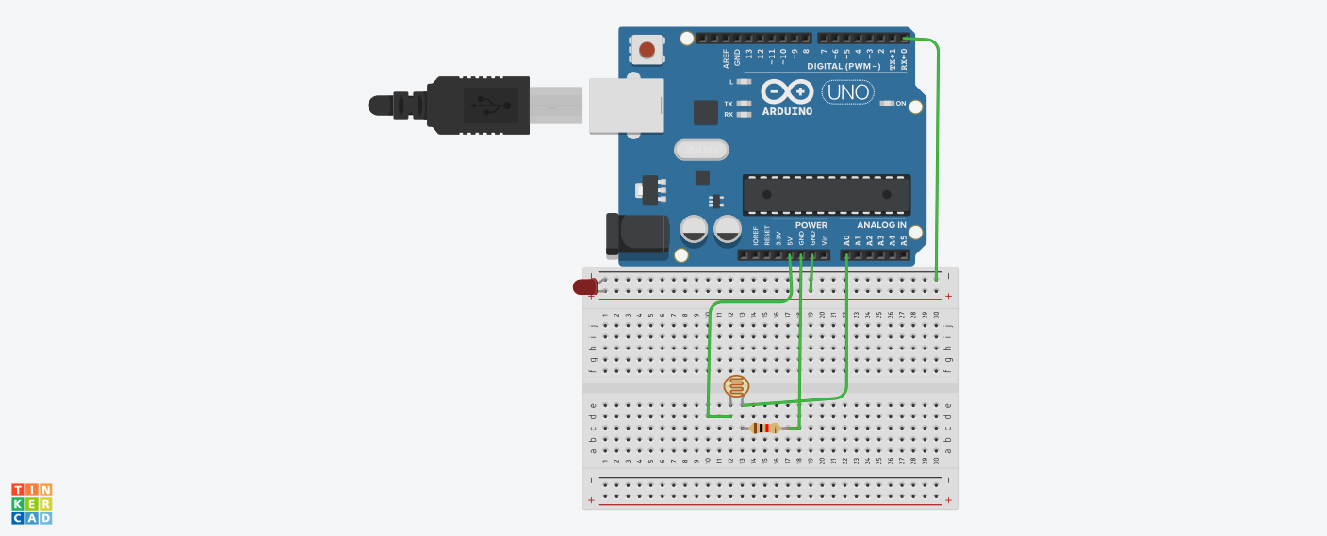**Theory:**

Concepts Used:

1. Using of LDR.
2. Coding Arduino.

**Learning & Observations**:

Learned the use of ldr.Understood the use of LDR.

There are many uses of LDR. We can make many useful devices like using LDR.

**Problems & Troubleshooting**

The connections of ldr were made wrong.

Forget to declare the port of arduino.

**Precautions**

1. Check the LED,ldr and Arduino are working properly.
2. Declare pins used .
3. Declare pin to which the positive terminal of LED is connected.
4. Make connections of ldr properly.
5. Declare the port to which arduino is connected.

**Learning Outcomes**

Learned usage of ldr and it was really fun.Understood the uses of ldr . Things I learned will be very useful.